**MongoDB Task - 1 For the following question write the corresponding MongoDB queries**

1.Find all the information about each products

**MongoDB Compass Execution:**

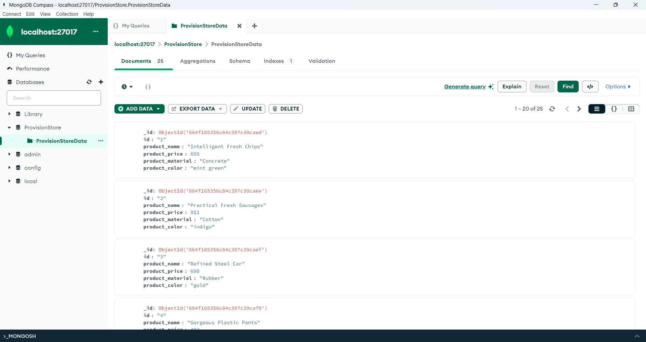

**Shell Execution:**

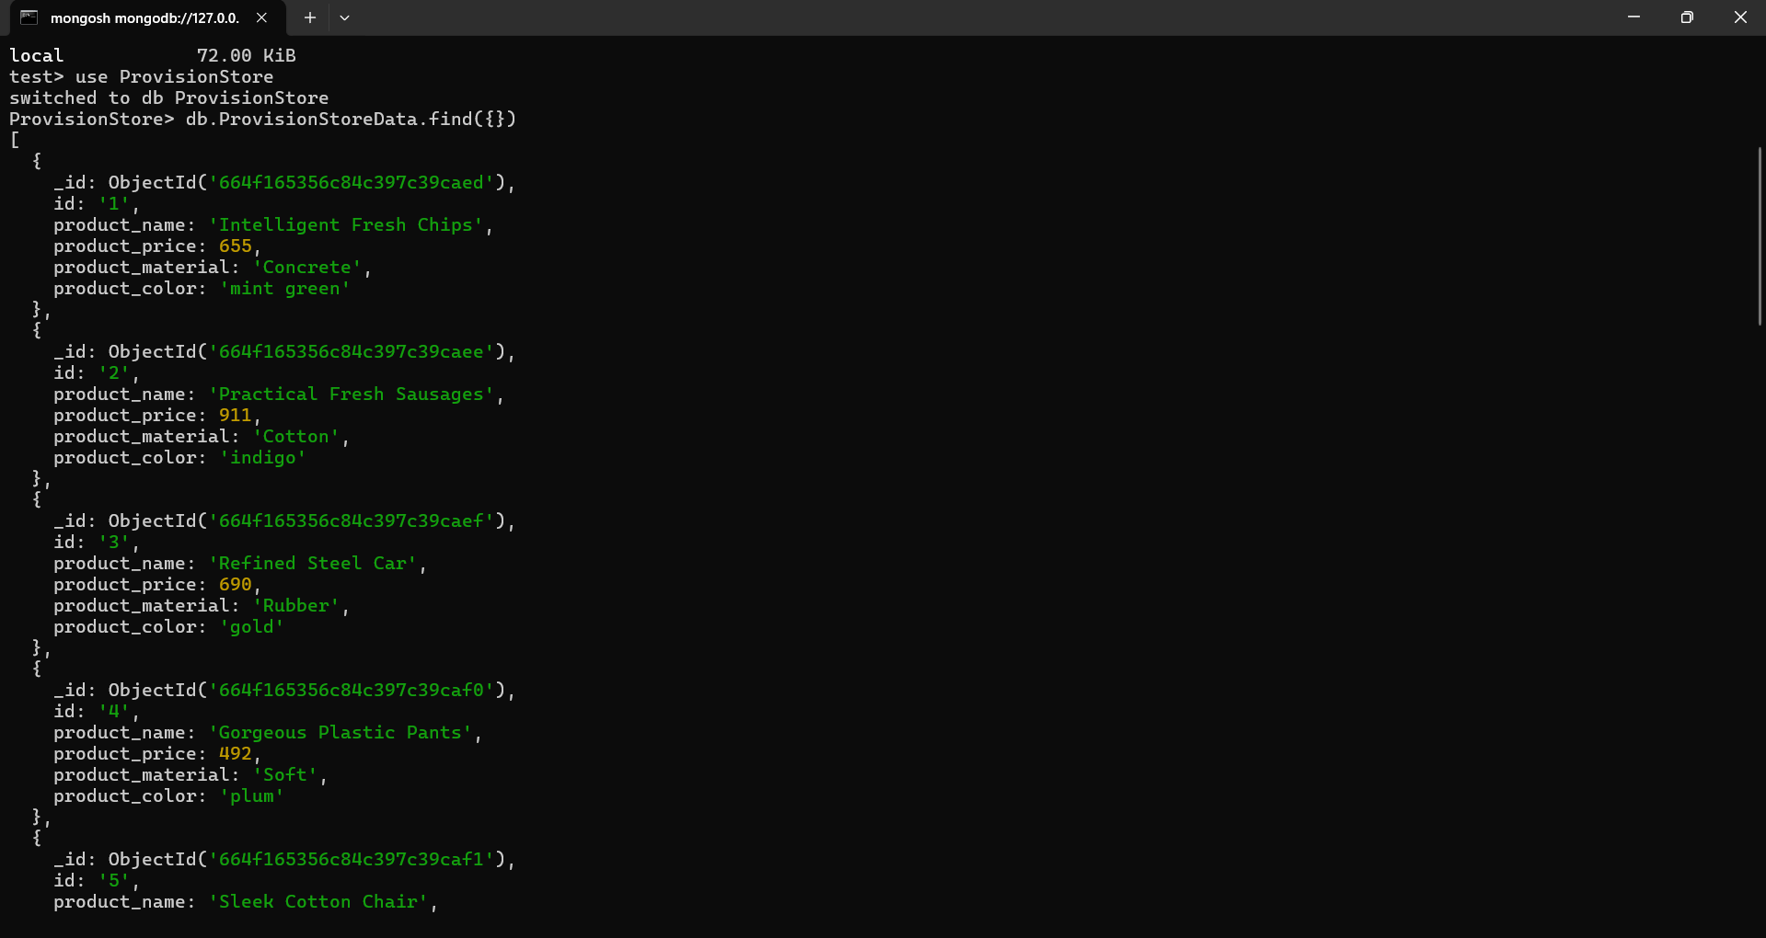

2.Find the product price which are between 400 to 800

**MongoDB Compass Execution:**

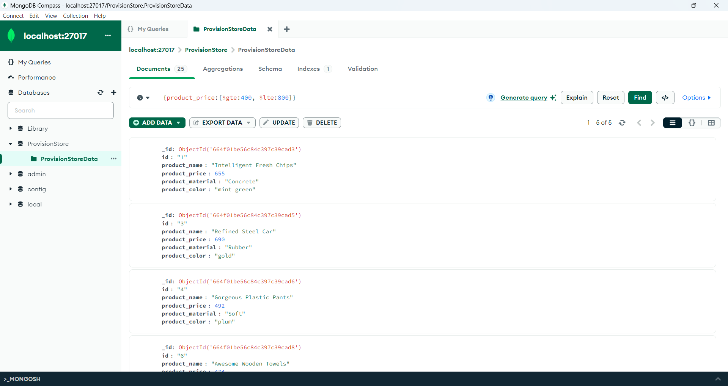

**Shell Execution:**

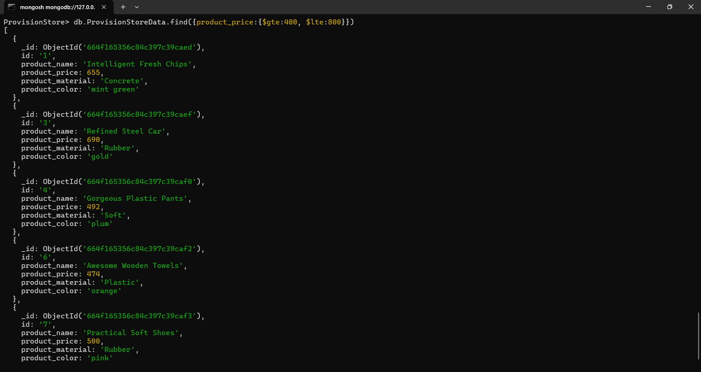

3.Find the product price which are not between 400 to 600

**MongoDB Compass Execution:**

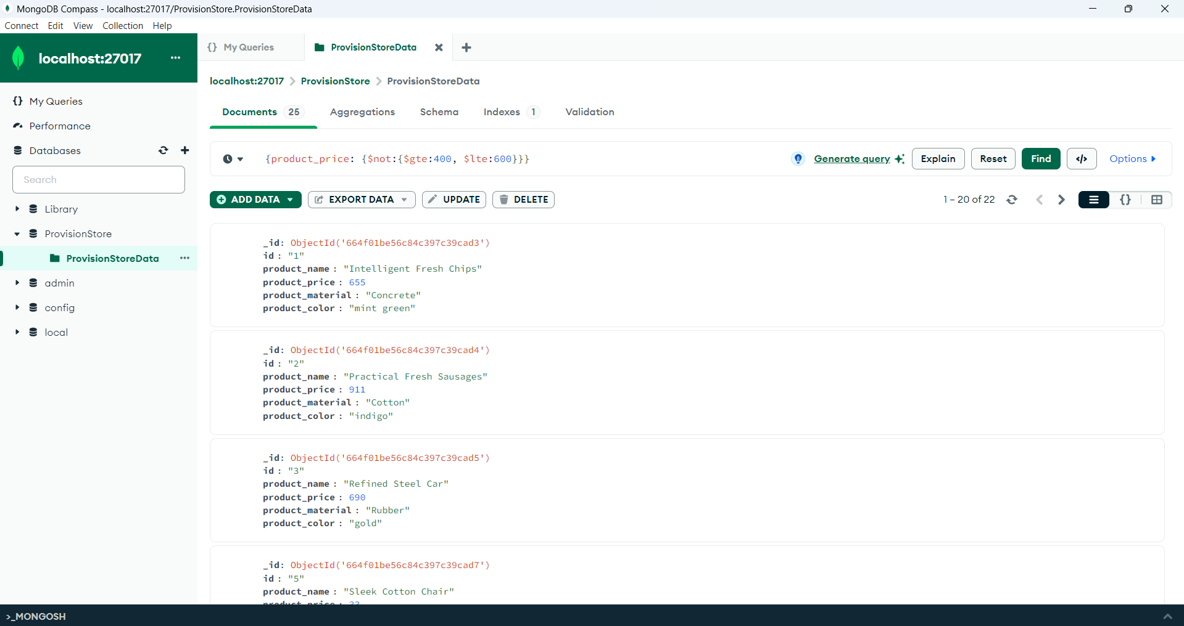

**Shell Execution:**

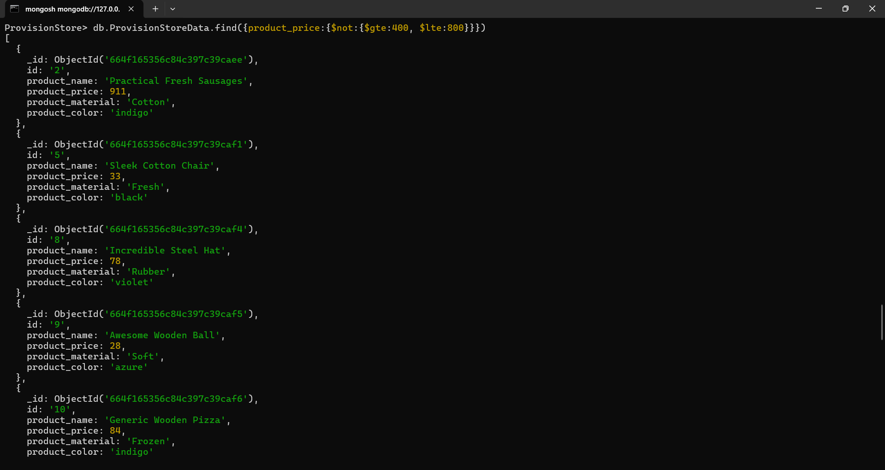

4.List the four product which are greater than 500 in price

**MongoDB Compass Execution:**

**Greater Than 500:**

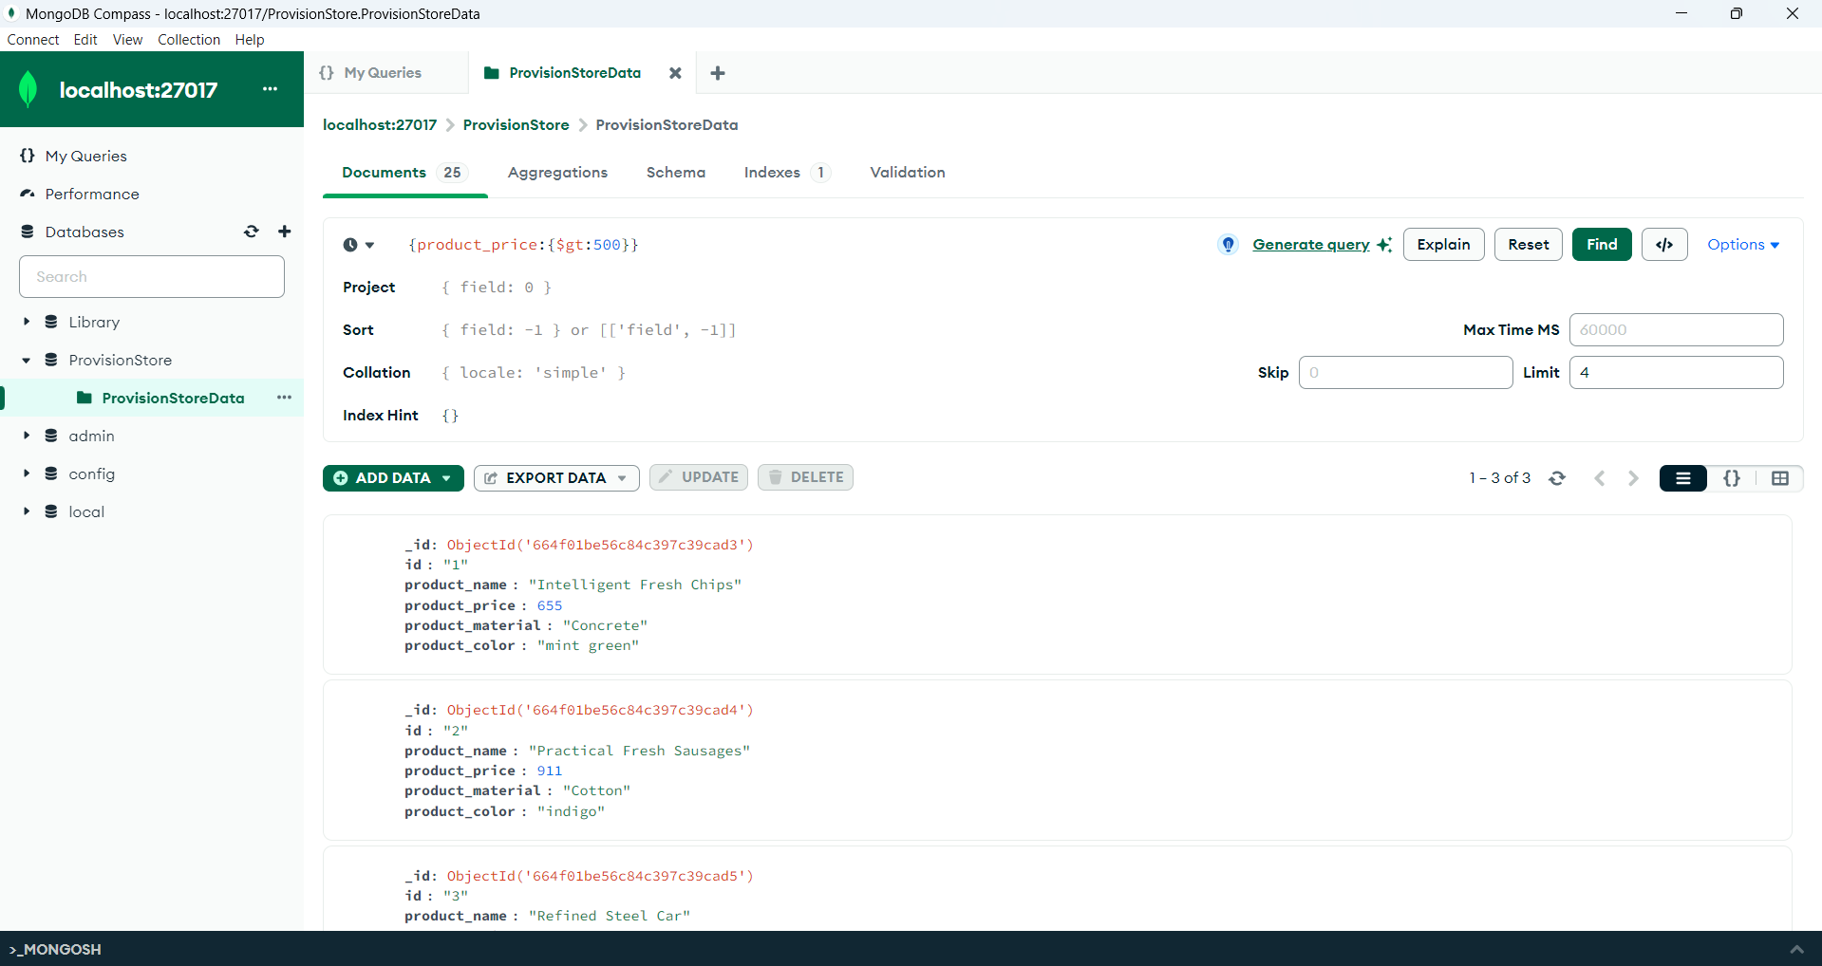

**Greater Than or Equal To 500:**

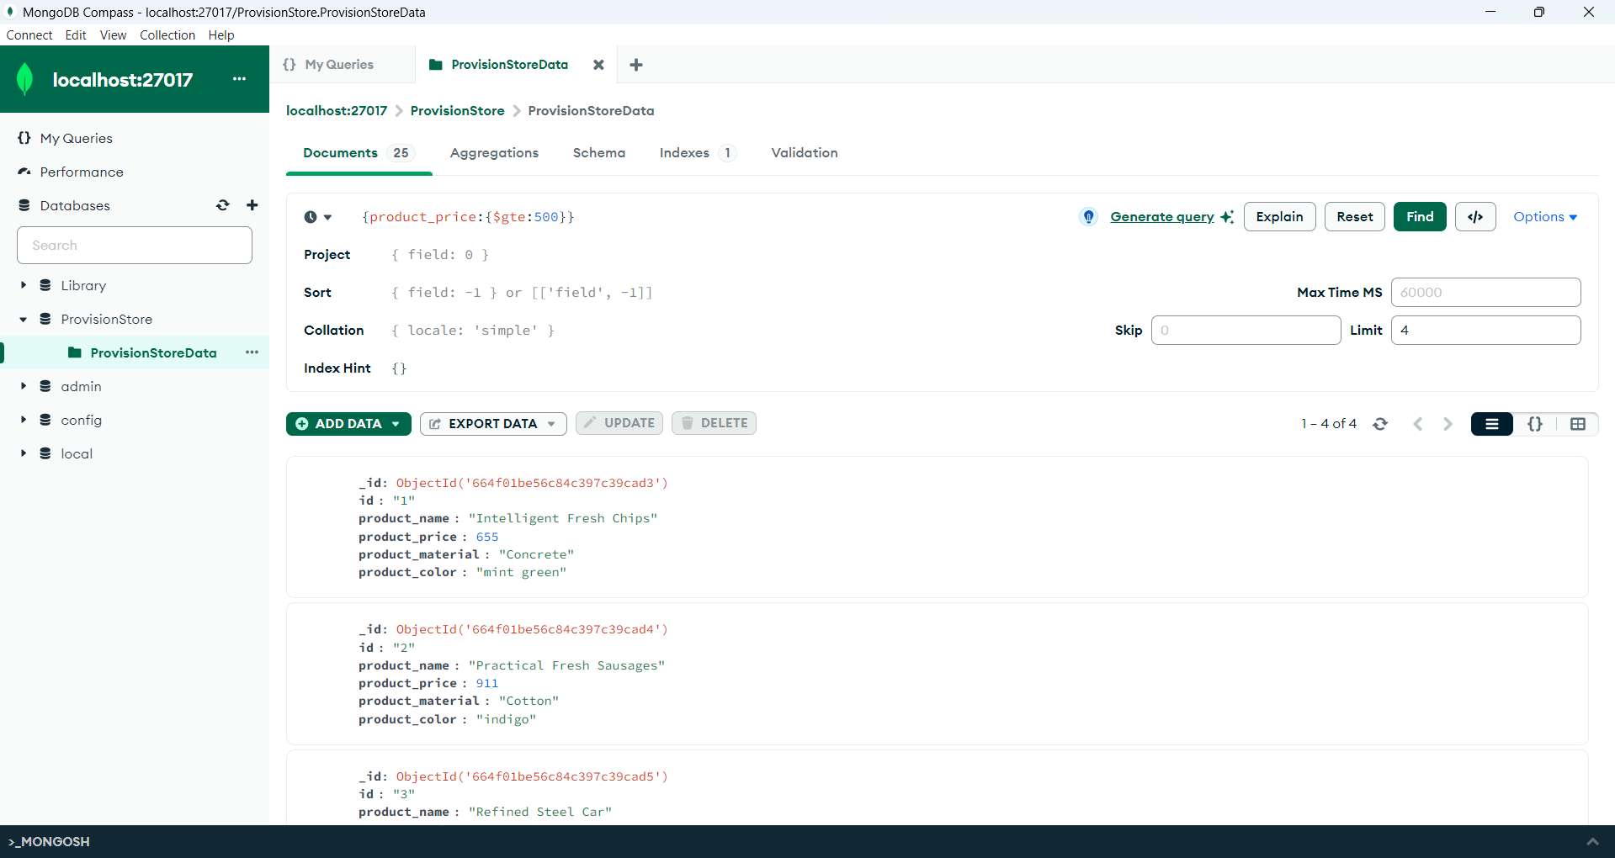

**Shell Execution:**

**Greater Than 500:**

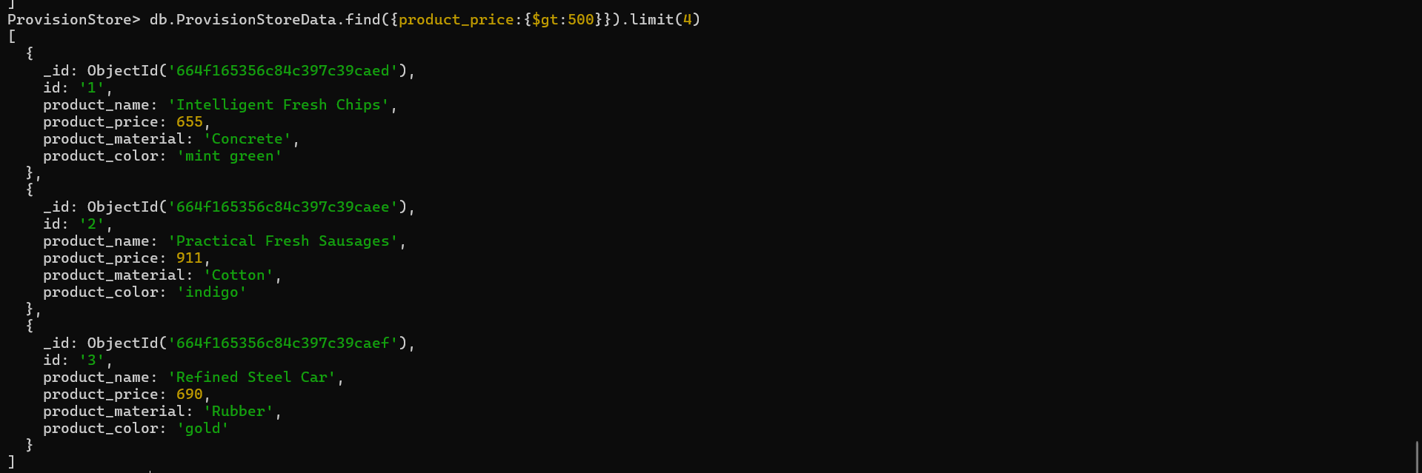

**Greater Than or Equal To 500:**

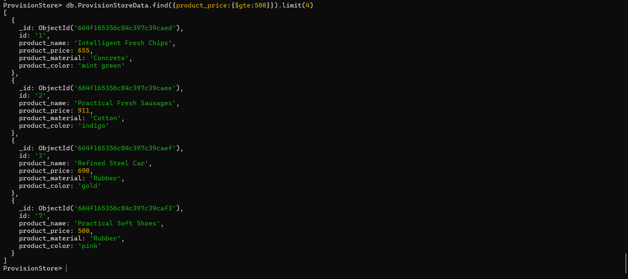

5.Find the product name and product material of each products

**MongoDB Compass Execution:**

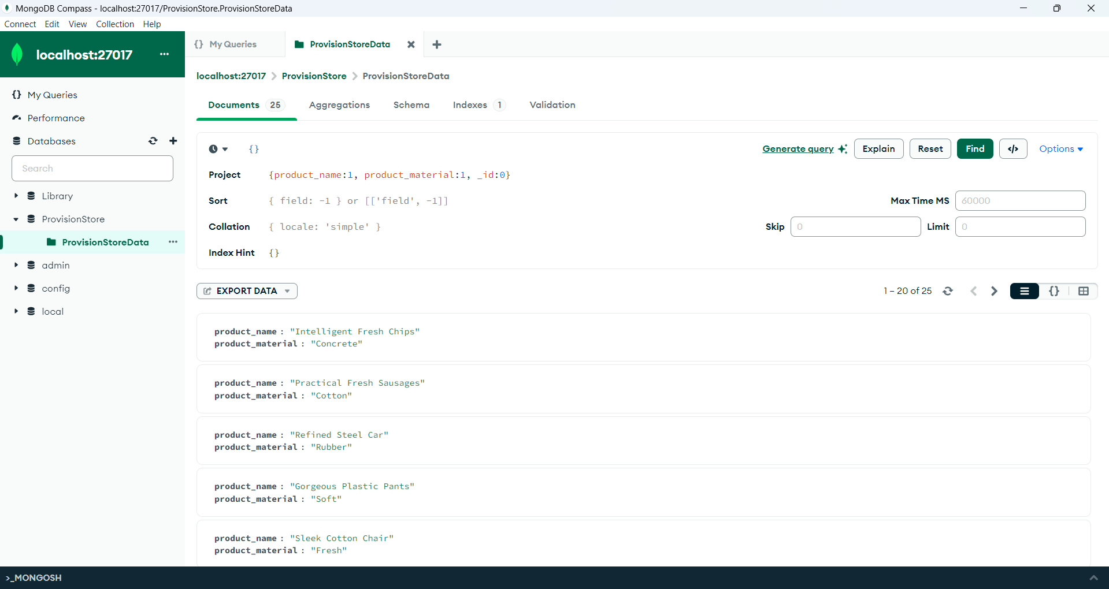

**Shell Execution:**

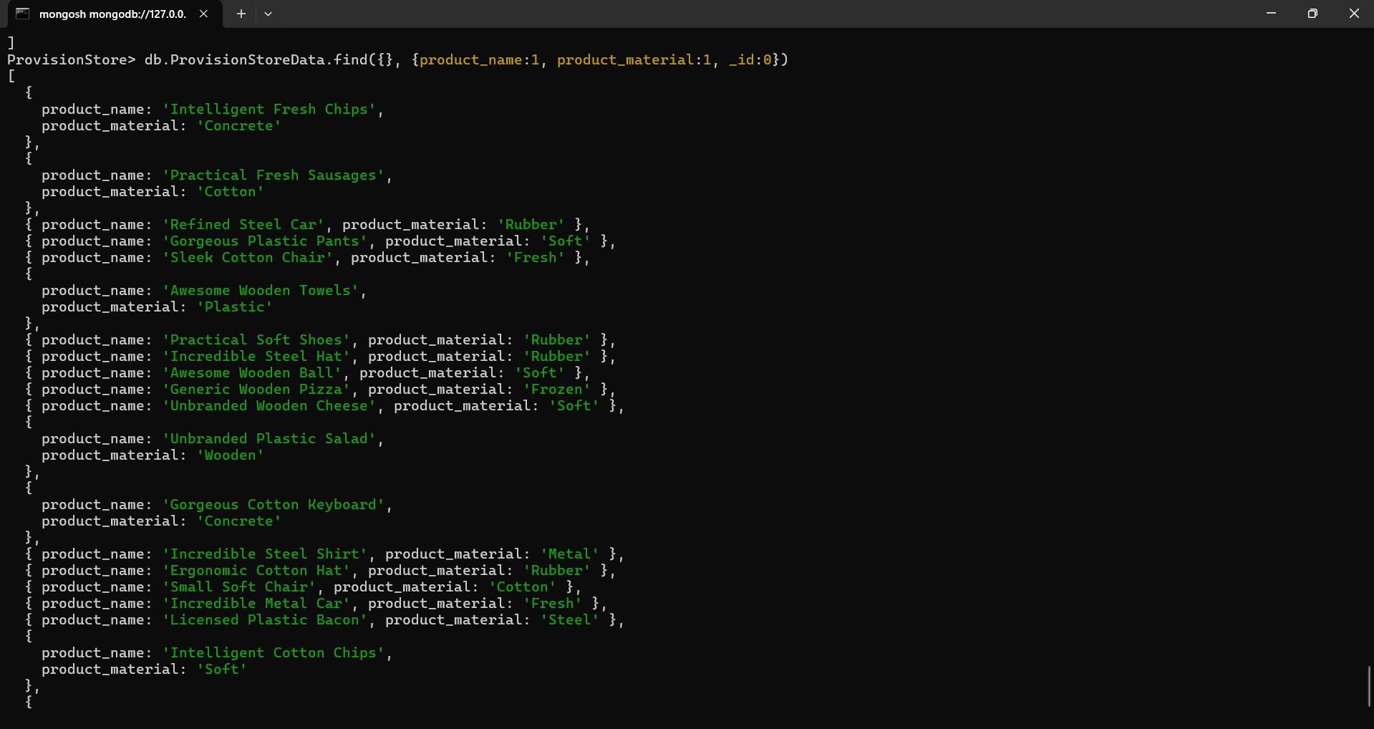

6.Find the product with a row id of 10

**MongoDB Compass Execution:**

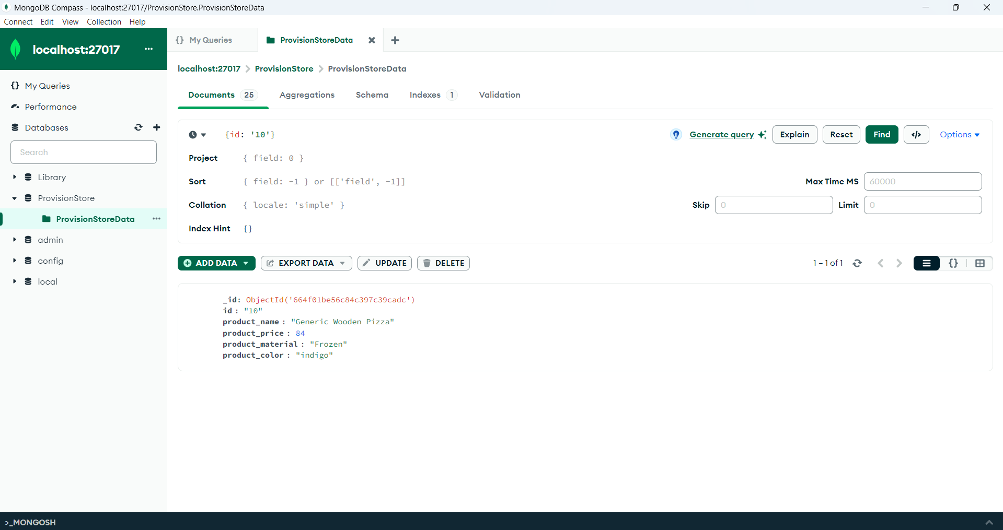

**Shell Execution:**

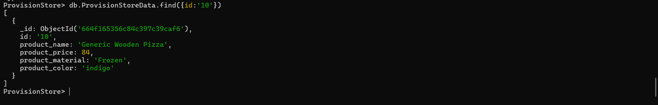

7.Find only the product name and product material

**MongoDB Compass Execution:**

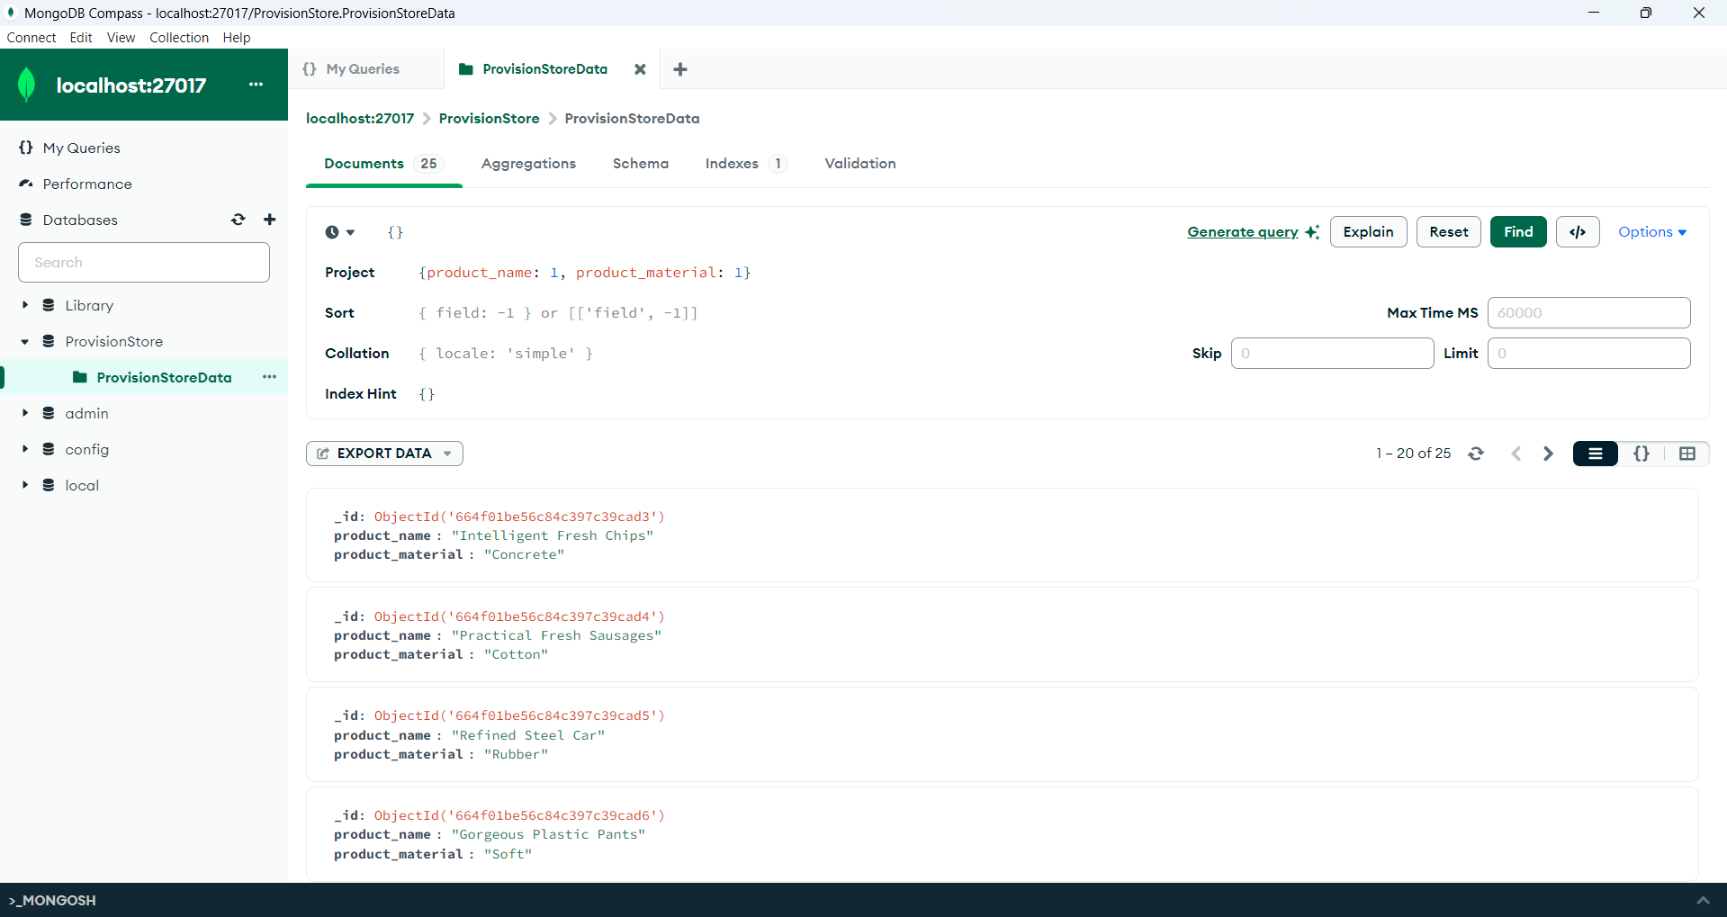

**Shell Execution:**



8.Find all products which contain the value of soft in product material

**MongoDB Compass Execution:**

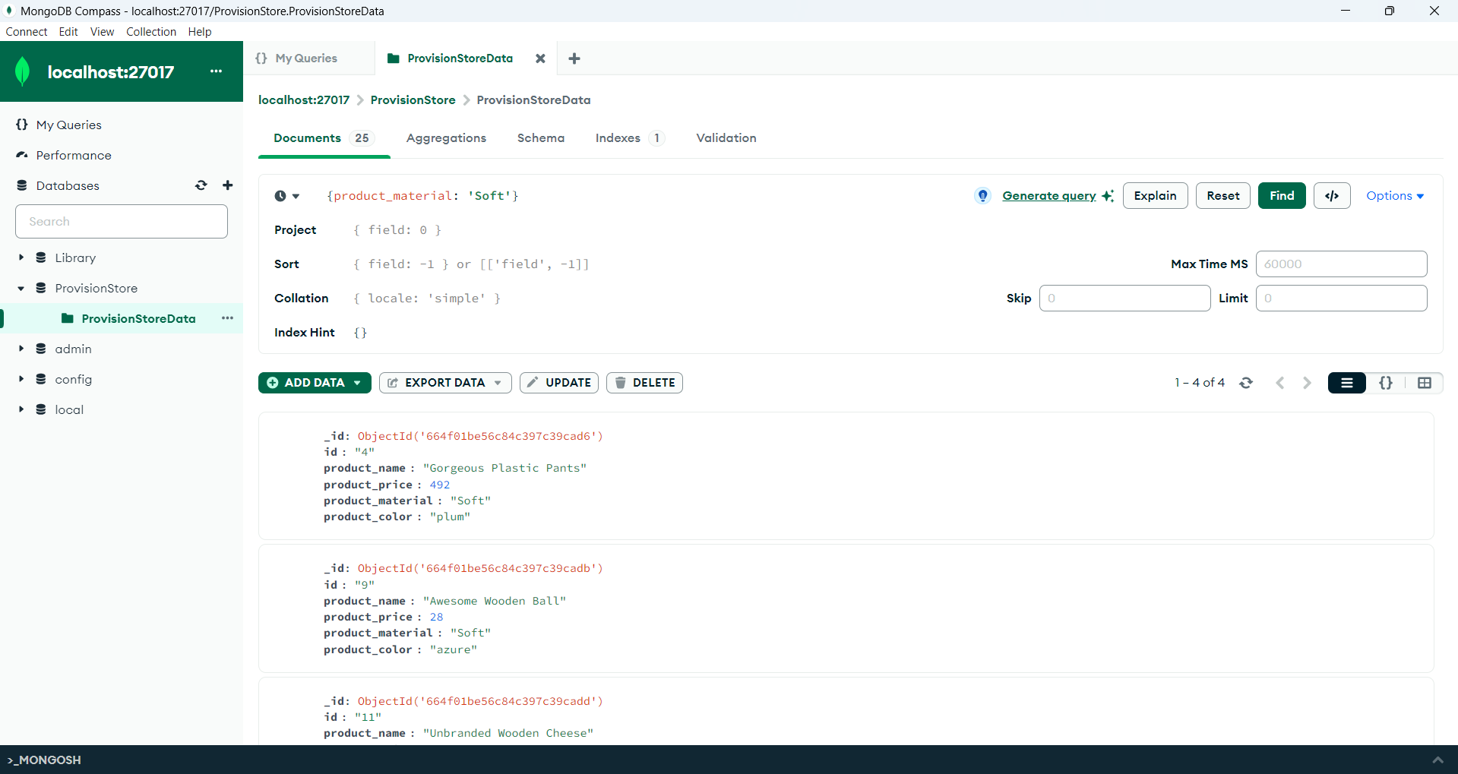

**Shell Execution:**

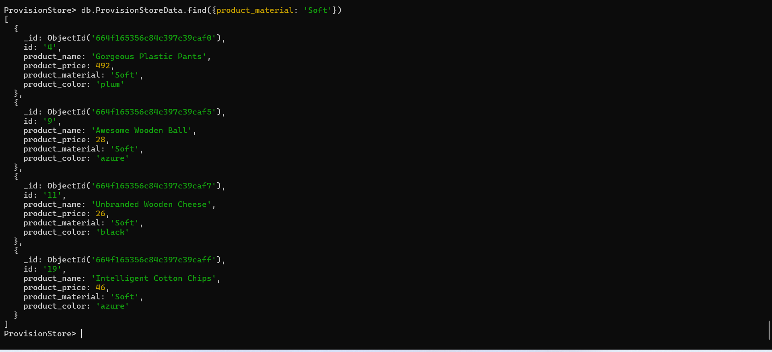

9.Find products which contain product color indigo and product price 492.00

**MongoDB Compass Execution:**

product color indigo

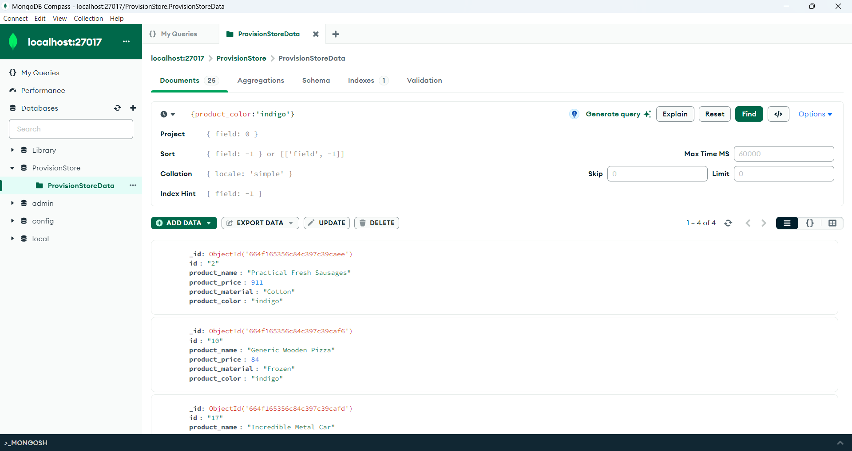

product price 492.00

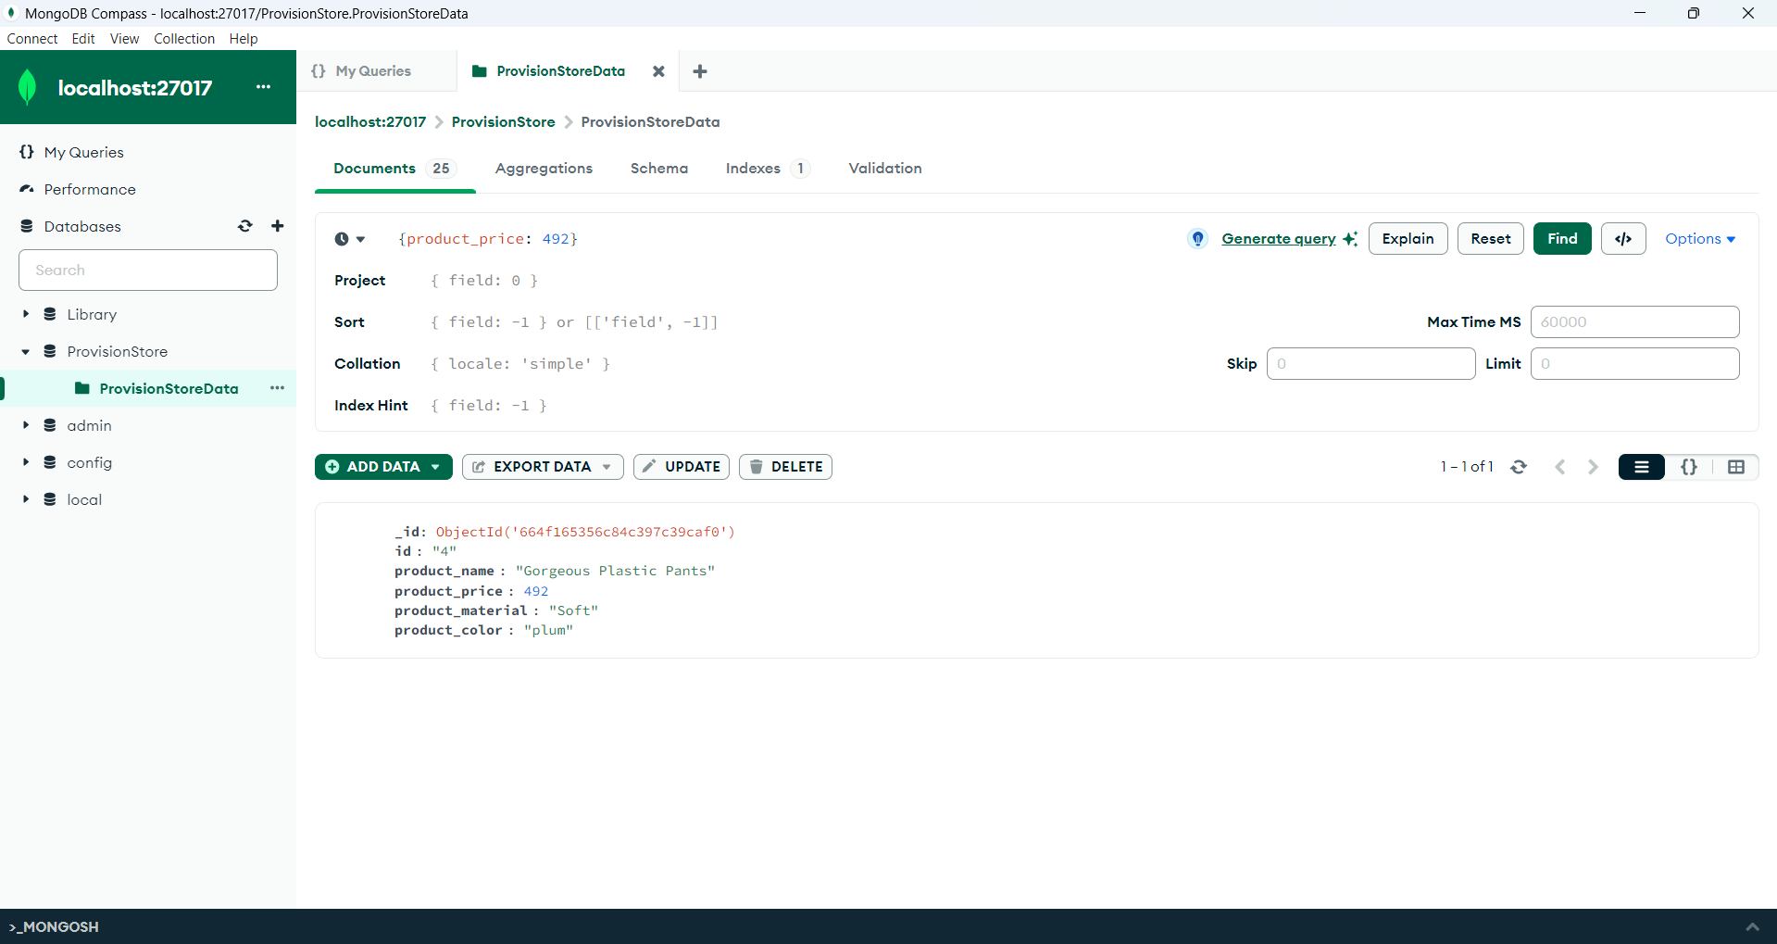

**Shell Execution:**

product color indigo

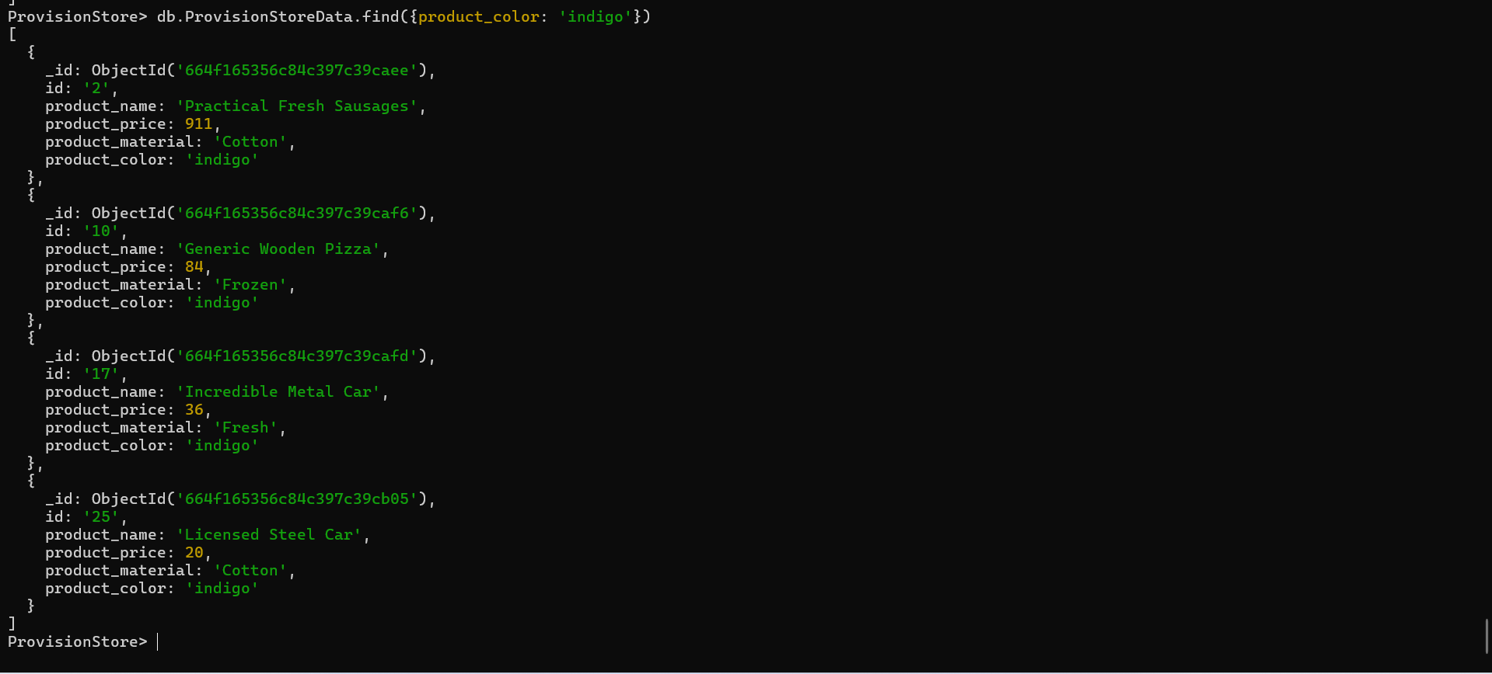

product price 492.00

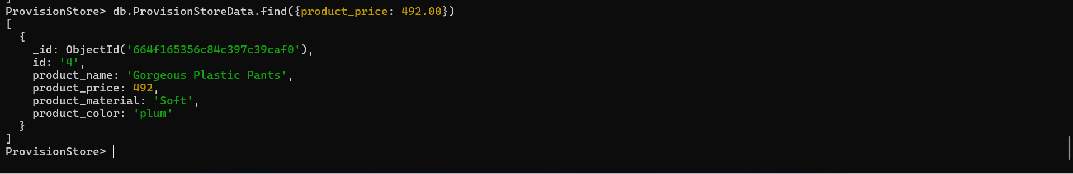

10.Delete the products which product price value are 28

Shell Execution:

